Fajar Qureshi
COMPUTER SCIENCE ATAR YEAR 12
Task 6 – Database Software Project
insert project title idk
Task 6 – Database Software Project

Table of Contents
Project outline: 2
Problem Description: 2
Functional requirements for the software: 2
Non-Functional requirements for the software: 2
Ethical, Legal and security Considerations: 2
Factors that may affect the quality and integrity of the stored data 3
Database Design 3
Entity Relationship Diagram (ERD): 3
Data Dictionary: 3
List of SQL Queries the software will perform 7
Software Design 8
Structure Chart 8
Function Specifications 8

Project outline:
The purpose of this project is to create an administration system for a company managing an online platform where its popular trading card game is conducted. The software will be designed for staff usage, and its objective will be to allow them to manage the card database, as well as maintain player accounts, create tournaments and monitor and track player activity such as collecting, trading and battling with cards.

Problem Description:
I have been asked by the Pokémon company to design and develop a software solution to manage an online platform where customers can play their new popular trading card game.
Using Python and SQL commands, I have to create an easy-to-use interface for authorised staff and admin to be able to interact with the platform’s database (that stores information on all of the existing cards, the players, tournaments, matches and player interactions), allowing them to add, edit, delete and search the database without typing SQL commands.

Functional requirements for the software:
My software should be able to:
- Authenticate the person using the software and authorize access accordingly (ie check if the login provided is of a staff or admin member)
- Allow staff to register new player accounts, and edit/delete old accounts
- Create and manage player accounts and decks
- Access, edit and manage the card database
- Create and manage tournaments (such as registering players, setting dates etc)
- Create search queries to find information on players, cards or tournaments/matches
- Generate reports and statistics from the database

Non-Functional requirements for the software:
My software should have:
- A simple, easy to use interface
- Options to select from rather than allowing typed searches where not necessary
- Simple queries and options for common functions required by staff
- Authentication methods
- Data to be verified and backed up to ensure reliability and security.

Ethical, Legal and security Considerations:
The created software will store the personal information of players, so to ensure it is kept ethically and securely, care will be taken to:
- Explicitly specify to the user what data is being collected, and for exactly what reason (APP 1)
- Not collect more data than necessary (APP 3)
- Restrict access to the database with the information using authentication and authorisation methods (APP 11)
- Have the data backed up to prevent loss due to data destruction or deletion. (APP 11)
The collection of personal information will be done in accordance to the Australian Privacy Principles detailed under the Privacy Act (1988), ensuring legal considerations have been made.

Factors that may affect the quality and integrity of the stored data
Data quality and integrity depend on accuracy, validity, and consistency throughout the data lifecycle. However, several factors compromise this storage:
- Invalid User Input: User or staff typos introduce incorrect email addresses or invalid date formats. This can be prevented using strict input validation boundaries.
- Incomplete Information: Missing mandatory fields break domain integrity, which requires data to fit defined ranges and types.
- Duplicate Records: Manual primary key entries can cause duplicate records, destroying entity integrity; this requires auto-incrementing keys.
- Broken Relationships: Deleting records can break referential integrity between tables, necessitating cascading deletes.

Database Design

Entity Relationship Diagram (ERD):
(image attached separately as well)
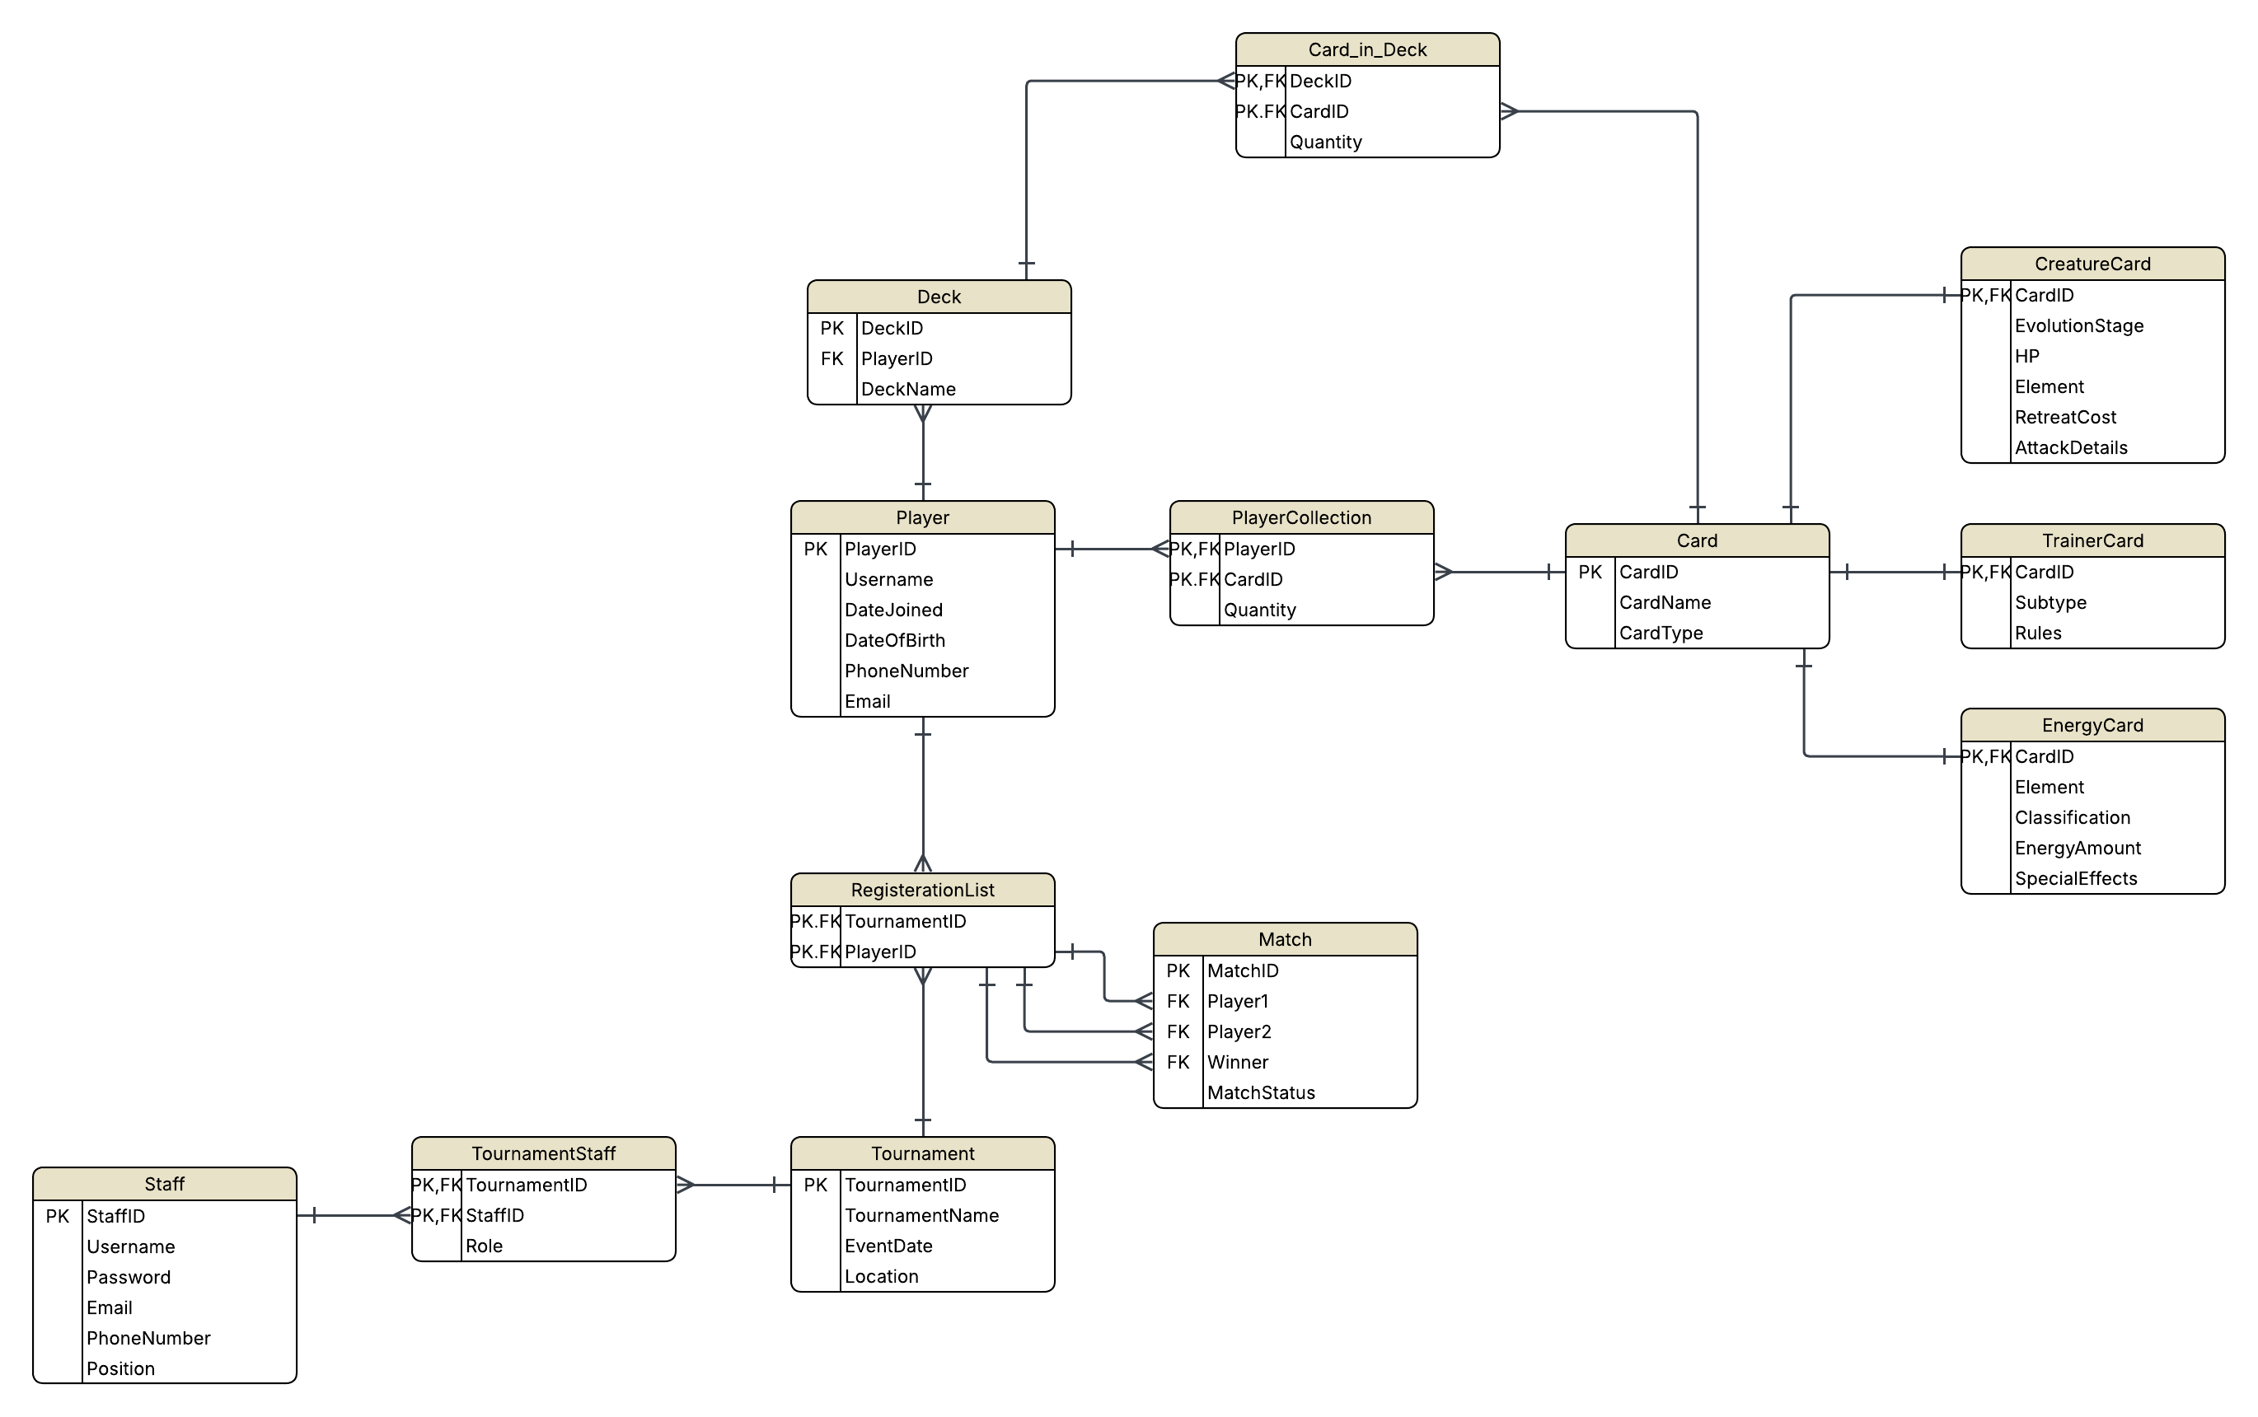

Data Dictionary:
(document attached separately as well (not yet))
Staff
Field Name | Data Type | Field Size (characters) | Key Type | Description | Constraints
StaffID | TEXT | 4 | PK | Unique staff ID | NOT NULL, UNIQUE
Username | TEXT | 50 | _ | Staff name | NOT NULL
Password | TEXT | 50 | _ | Player password | NOT NULL
Email | TEXT | 50 | _ | Player email | NOT NULL, Contain @
PhoneNumber | INTEGER | 17 | _ | Player’s registered phone number | NOT NULL
Position | TEXT | 50 | _ | Regular staff/ admin | From specific values, NOT NULL

Tournament Staff
TournamentID | TEXT | 4 | PK, FK | Tournament ID | NOT NULL
StaffID | TEXT | 4 | PK, FK | Staff member ID | NOT NULL
Role | TEXT | 50 | _ | Position in the tournament (manager, match organiser) | From specific values, NOT NULL

Tournament
TournamentID | TEXT | 4 | PK | Unique identifier | NOT NULL, UNIQUE
TournamentName | TEXT | 50 | _ | Tournament name | NOT NULL
Location | TEXT | 50 | _ | Tournament server/physical venue | NOT NULL
EventDate | TEXT | 10 | _ | Date of the tournament | NOT NULL, date format

Registeration List
TournamentID | TEXT | 4 | PK, FK | Tournament ID | NOT NULL
PlayerID | TEXT | 4 | PK, FK | Player registered for the tournament | NOT NULL

Match
MatchID | TEXT | 4 | PK, FK | Unique match ID | NOT NULL, UNIQUE
Player1 | TEXT | 4 | FK | Player_ID of the first player | NOT NULL
Player2 | TEXT | 4 | FK | Player_ID of the second player | NOT NULL, diff from player1
Winner | TEXT | 4 | FK | Player_ID of the winner | NOT NULL, from player1 OR player 2
MatchStatus | TEXT | 50 | _ | To be played/in progress/completed | NOT NULL, from specific values.

Player
PlayerID | TEXT | 4 | PK | Unique player identifier | NOT NULL, UNIQUE
Username | TEXT | 20 | _ | Player chosen username | NOT NULL
DateJoined | TEXT | 10 | _ | Date joined | set automatically, follow date format
DateOfBirth | TEXT | 10 | _ | Date of birth | NOT NULL, follow date format
PhoneNumber | INTEGER | 17 | _ | Player’s registered phone number
Email | TEXT | 30 | _ | Payer’s registered email address | NOT NULL, contain @

Deck
DeckID | TEXT | 4 | PK | Uniquecidentifier for deck | NOT NULL, UNIQUE
PlayerID | TEXT | 4 | FK | Player the deck belongs to | NOT NULL
DeckName | TEXT | 50 | _ | Name of Deck | NOT NULL

Card_In_Deck
DeckID | TEXT | 4 | PK, FK | Unique deck ID | NOT NULL
CardID | TEXT | 4 | PK, FK | Card ID | NOT NULL, UNIQUE
Quantity | INTEGER | 2 | _ | Number of a specific card in a deck | NOT NULL

PlayerCollection
PlayerID | TEXT | 4 | PK, FK | ID of the player the cards belong to | NOT NULL
CardID | TEXT | 4 | PK, FK | The card that belongs to the player | NOT NULL, UNIQUE
Quantity | INTEGER | 3 | _ | Number of this specific card the player owns. | Quantity > 0

Card
CardID | TEXT | 4 | PK | Unique identifier for each card | NOT NULL, UNIQUE
CardName | TEXT | 50 | _ | Card name | NOT NULL
CardType | TEXT | 50 | _ | Pokemon/trainer/energy card | NOT NULL

CreatureCard
CardID | TEXT | 4 | PK, FK | Unique identifier for each card | NOT NULL, UNIQUE
EvolutionStage | TEXT | 50 | _ | Basic pokemon, stage 1, stage 2 etc | NOT NULL
HP | INTEGER | 3 | _ | Health points | NOT NULL
Element | TEXT | 50 | _ | Element | NOT NULL
RetreatCost | INTEGER | 2 | _ | Energy cost to retreat pokemon | NOT NULL
AttackDetails | TEXT | 500 | _ | Various attacks the pokemon can perform

TrainerCard
CardID | TEXT | 4 | PK, FK | Unique identifier for each card | NOT NULL, UNIQUE
Subtype | TEXT | 50 | _ | Tool, stadium, item etc | NOT NULL
Rules | TEXT | 100 | _ | Specific effects of the card

EnergyCard
CardID | TEXT | 4 | PK, FK | Unique identifier for each card | NOT NULL, UNIQUE
Element | TEXT | 50 | _ | Element | NOT NULL
Classification | TEXT | 50 | _ | Normal, special etc | NOT NULL
EnergyAmount | INTEGER | 4 | _ | Amount of energy | NOT NULL
SpecialEffects | TEXT | 200 | - | Special effects of the card

List of SQL Queries the software will perform
Player Queries
- Provide details of a particular player.
- Search for players by username or email.
- Edit player details.
- Add/delete player accounts.
- Display all tournaments a player has entered.
- Show all decks owned by a player.
- Count the number of decks a player owns.
- Calculate the total number of cards owned by a player.
- Display the player's most valuable deck (if you store card values).
Card Queries
- Provide details of a specific card.
- Search cards by name.
- Search cards by element/type.
- Search cards by rarity.
- Display cards with HP greater than a specified value.
- Display cards sorted by HP (highest to lowest).
- Count the number of cards for each rarity.
- Count the number of cards of each element/type.
- Add/edit/delete cards.
Deck Queries
- Display all cards in a selected deck.
- Count the number of cards in a deck.
- Count the number of cards of each type within a deck.
- Display all decks containing a specific card.
- Create/edit/delete decks.
Tournament Queries
- Display details of a tournament.
- Register/remove players from tournaments.
- Count the number of players registered for each tournament.
- Display all upcoming tournaments.
- Display tournaments ordered by date.
- Add/edit/delete tournaments.
Match Queries
- Create/edit/delete matches.
- Display details of a specific match
- Display all matches in a tournament.
- Display all matches played by a selected player.
- Display the winner of each match.
- Count the total number of matches in a tournament.
Staff Queries
- Display staff details.
- Search staff by name or role.
- Add/edit/delete staff accounts (if staff management is included).
Reports & Statistics
- Display the players with the largest card collections.
- Display the most commonly owned card.
- Display the rarest cards in the database.
- Calculate the average HP of all cards.
- Calculate the maximum and minimum HP.
- Display the total number of players.
- Display the total number of cards.
- Display the total number of tournaments.
- Display the total number of registered tournament entries.

Software Design

Structure Chart

Function Specifications
Function name, purpose, parameters, return values, brief description of the processing performed.

Function name | Purpose | Parameters | Return values | Description
Main() | Main function that encompasses all the other functions | none | none | Call all other functions
Login() | Displays home screen with login page. Authenticates user and authorizes specific tasks they can do, showing an options page of queries they can make. | Username, password | Boolean (True/False) | Accept username and password, compare it against database values, grant or deny access.
View_Details() | Displays all details for a particular thing, searching by a specific field. | Table, field, search value | record | First parameter indicates which table to check, second parameter indicates which field to search by, compare parameter with values in table, SELECT WHERE record if found.
Edit_Details() | Edit the details of a player/staff | Id/field/data | none | Finds record with id, UPDATE
Add_smt() | Add a new player, staff, tournament/match/deck | All fields in a record | Boolean indicating success | Validate input, execute an INSERT, commit changes
Delete_smt() | Remove a specific record from the database | Id/field/data | Boolean indicating success | DELETE and commit changes
Register_player() | Register a player for a tournament | Player_id, tournament_id | Boolean indicating success | Validate input, INSERT registration record, commit changes
Create_match | Creates a match between two players ni a specific tournament | Player1_id, player2_id, tournament_id | Boolean indicating success | Validate input, INSERT new match record, commit changes
Display_Sorted() | Display records sorted by a chosen field. | table, field, sort | List of records | SELECT  ORDER BY
Count_Items() | Count records that match a specified condition. | table, category | Integer | Executes a COUNT() query (e.g. number of decks owned, players in a tournament, total players/cards/tournaments).
Display_Player_Decks() | Display all decks owned by a selected player. | player_id | List of decks | Retrieves every deck linked to the specified player using a SELECT WHERE query.
Display_Deck_Cards() | Display every card in a selected deck. | deck_id | List of cards | Retrieves all cards and quantities stored in the chosen deck using a join between Deck and Card_In_Deck.
Display_Upcoming_Tournaments() | Display all tournaments that have not yet occurred. | Current date | List of tournaments | Uses a SELECT query with a date comparison to retrieve future tournaments ordered by date.
Calculate_Card_Statistics() | Calculate statistical information about creature cards. | statistic_type | Numeric value | Executes aggregate SQL queries (AVG(), MAX(), MIN()) to calculate the average, maximum or minimum HP values of creature cards.
Count_total() | Display the total number of players/cards/registerations/tournaments/cards in deck | none | Integer | Executes a COUNT() query on the specific table.
Calculate_Max/MIN/AVG _HP() | Calculate the maximum or minimum or average HP values. | none | Max/min/avg and recods of cards with those | Executes MAX() or MIN() or AVG() queries on the HP field of the CreatureCard table and displays the results.

Function name | Purpose | Parameters | Return values | Description
Display_Largest_Collections() | Display the players with the largest card collections. | none | List of players | Executes a query to retrieve players ordered by the total number of cards in their collections (highest to lowest).
Display_Most_Common_Card() | Display the most commonly owned card. | none | Card record | Counts the total quantity of each card owned by players and displays the card with the highest total.
Display_Rarest_Cards() | Display the rarest cards in the database. | none | List of cards | Retrieves the cards with the lowest total ownership across all player collections.

